CSE 2320 Notes 13: Hashing

(Last updated 11/8/26 3:01 PM)

CLRS 11.1-11.4 (skip 11.3.3)

13.A. Concepts

Goal: Achieve faster operations than balanced trees (nearly 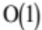 expected time) by using “randomness” in key sets by sacrificing 1) generality and 2) ordered retrieval.

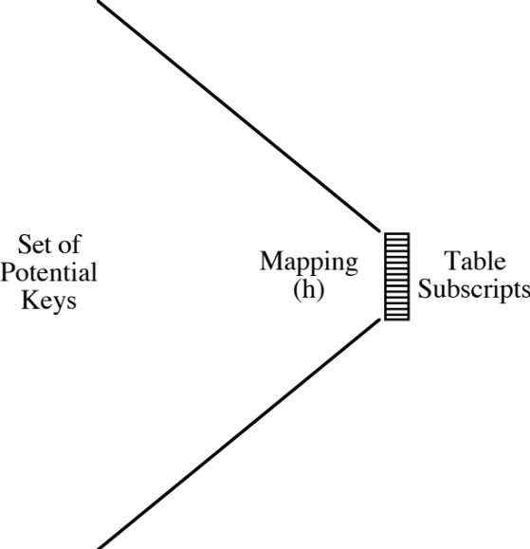

Regardless of the hash function, a dynamic set of keys will lead to collisions.

Birthday paradox

366 different birthdays available

How many (random) persons are needed to have at least even odds of two persons with the
same birthday? 23

Probability of k persons having k different birthdays is 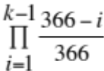

probability of unique birthdays among 0 people is 1
probability of unique birthdays among 1 people is 1
probability of unique birthdays among 2 people is 0.997268
probability of unique birthdays among 3 people is 0.991818
probability of unique birthdays among 21 people is 0.557221
probability of unique birthdays among 22 people is 0.525249
probability of unique birthdays among 23 people is 0.493677
probability of unique birthdays among 24 people is 0.462654
probability of unique birthdays among 57 people is 0.0100102
probability of unique birthdays among 58 people is 0.00845124
13.B. Hash Functions

Modular (AKA remaindering or division method)

h(key) = key % m

m is the table size

Folklore: Make m prime, regardless of collision handling technique. Double hashing requires.

Multiplicative

hash = m * (0.710123587*key - (int)(0.710123587*key));

Universal Hashing - aside

Use parameterized hash function to minimize chance of getting collisions beyond expectation.

Parameters are randomly generated when hash structure is initialized.

Text Strings as Key

scanf("%s",str);
hash=0;
for (i=0;
str[i]!=0;
i++)
hash = (hash*10 + str[i]) % m;
printf("%s => %d\n",str,hash);

A string’s signature may be stored in a data structure, even if hashing is not used.

13.C. Collision Handling by Chaining

Concept – Use table of pointers to unordered linked lists. Elements of a list have the same signature.

Load Factor 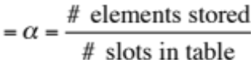

Often stated as a per cent. For some methods, such as chaining, α can exceed 100%.

Expected probes is 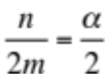 for hits and 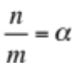 for misses.

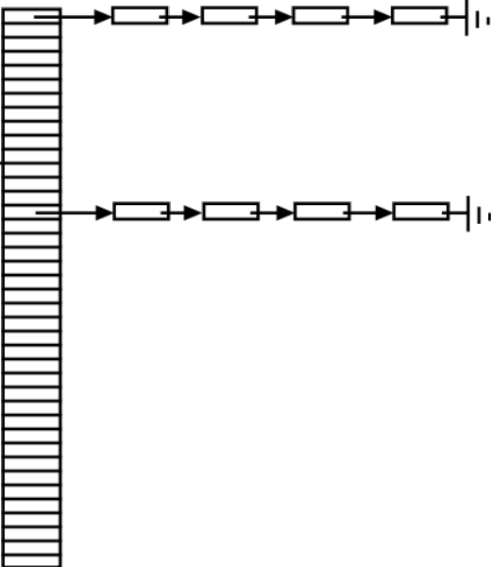

13.D. Collision Handling by Open Addressing

Saves space when records are small, so chaining would waste a large fraction of space for links.

Collisions are handled by using a probe sequence for each key – a permutation of the table’s subscripts.

Hash function is h(key, i) where i is the number of reprobe attempts tried.

Two special key values (or flags) are often used: never-used (-1) and recycled (-2). Searches stop on never-used, but continue on recycled. (For linear probing, but not double hashing - can also reinsert records past the emptied slot for a deletion.)

Linear Probing - h(key, i) = (key + i) % m ( http://ranger.uta.edu/~weems/NOTES2320/hashLP.c )

Properties:

1. Probe sequences eventually hit all slots.

2. Probe sequences wrap back to beginning of table.

3. Long clusters of contiguous occupied slots are costly for misses.

4. There are only m probe sequences. Two keys hashing to same initial slot have the same probe sequence.

What about using h(key, i) = (key + 2*i) % 101 or h(key, i) = (key + 50*i) % 1000?
Suppose all keys are equally likely to be accessed. Is there a best order for inserting keys?

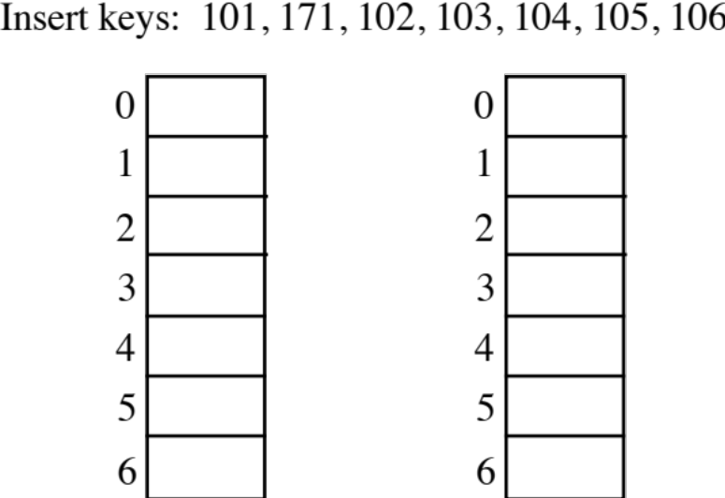

Double Hashing – h(key, i) = (h₁(key) + i*h₂(key)) % m
( http://ranger.uta.edu/~weems/NOTES2320/hashDH.c )

Properties:

1. Probe sequences will hit all slots only if m is prime.

2. m(m – 1) probe sequences. Unlikely that two keys hashing to the same initial slot will have the same probe sequence.

3. Minimizes effect of clustering.

Typical Hash Functions:

h₁ = key % m

h₂ = 1 + key % (m – 1)

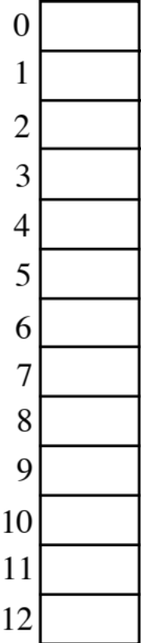
Key h₁ h₂
1313 0 6
2626 0 11
24 11 1
19 6 8
136 6 5
140 10 9
23 10 12
29 3 6
2600 0 9
1305 5 10

13.E. Upper Bounds on Expected Performance for Open Addressing

Double hashing comes very close to these results, but analysis assumes that hash function provides
all m! permutations of subscripts.

1. Unsuccessful search when load factor is 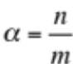. Each successive probe has the effect of decreasing both the number of slots in the table and the number of occupied slots by one.

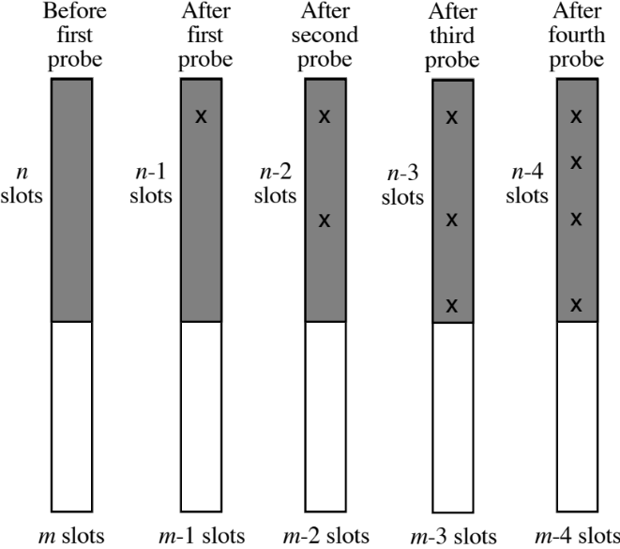
a. Probability that a search has a first probe 1

b. Probability that search goes on to a second probe

c. Probability that search goes on to a third probe 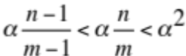

d. Probability that search goes on to a fourth probe 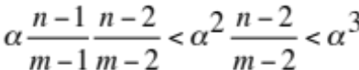

. . .

Suppose the table is large. Sum the probabilities for probes to get upper bound on expected number of probes:

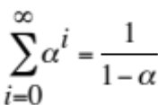 (much worse than chaining)

2. Inserting a key when load factor is α

a. Exactly like unsuccessful search

b. Upper bound of 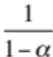 probes

3. Successful search

a. Searching for a key takes as many probes as inserting that particular key.

b. Each inserted key increases the load factor, so the inserted key number i + 1 is expected
to take no more than

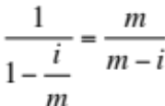 probes

c. Find expected probes for n keys inserted into an empty table (each key is equally likely to be requested):

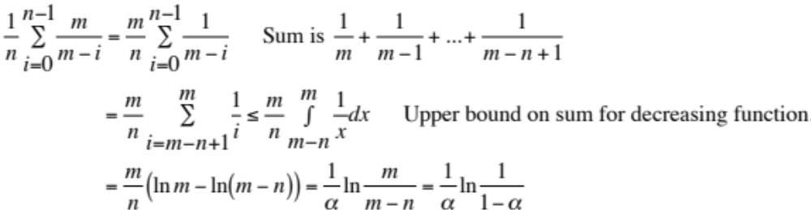

alpha 0.200 unsuccessful (insert) 1.250 successful 1.116
alpha 0.250 unsuccessful (insert) 1.333 successful 1.151
alpha 0.300 unsuccessful (insert) 1.429 successful 1.189
alpha 0.350 unsuccessful (insert) 1.538 successful 1.231
alpha 0.400 unsuccessful (insert) 1.667 successful 1.277
alpha 0.450 unsuccessful (insert) 1.818 successful 1.329
alpha 0.500 unsuccessful (insert) 2.000 successful 1.386
alpha 0.550 unsuccessful (insert) 2.222 successful 1.452
alpha 0.600 unsuccessful (insert) 2.500 successful 1.527
alpha 0.650 unsuccessful (insert) 2.857 successful 1.615
alpha 0.700 unsuccessful (insert) 3.333 successful 1.720
alpha 0.750 unsuccessful (insert) 4.000 successful 1.848
alpha 0.800 unsuccessful (insert) 5.000 successful 2.012
alpha 0.850 unsuccessful (insert) 6.667 successful 2.232
alpha 0.900 unsuccessful (insert) 10.000 successful 2.558
alpha 0.910 unsuccessful (insert) 11.111 successful 2.646
alpha 0.920 unsuccessful (insert) 12.500 successful 2.745
alpha 0.930 unsuccessful (insert) 14.286 successful 2.859
alpha 0.940 unsuccessful (insert) 16.666 successful 2.993
alpha 0.950 unsuccessful (insert) 20.000 successful 3.153
alpha 0.960 unsuccessful (insert) 25.000 successful 3.353
alpha 0.970 unsuccessful (insert) 33.333 successful 3.615
alpha 0.980 unsuccessful (insert) 49.998 successful 3.992
alpha 0.990 unsuccessful (insert) 99.993 successful 4.652

“Fast and Powerful Hashing Using Tabulation”, CACM 60 (7), July 2017,
https://dl-acm-org.ezproxy.uta.edu/citation.cfm?id=3068772

